**About Magnetic Fields**

The Magnetic Fields visualization tool is a cross-platform mobile application made using the Unity3d framework. It is written primarily in C#, as a set of C# scripts that can be optionally added to GameObject instances created within the Unity3d IDE. Classes in the Magnetic Fields codebase therefore mostly extend UnityEngine’s MonoBehavior class. The complete codebase is available for download at http://github.com/charlielobster/MagneticFields

Magnetic Fields uses Unity3d’s AR Foundation, Unity3d’s augmented reality toolkit. AR Foundation in turn rides on top of AR Core or AR Kit implementations which were created by Google and Apple, respectively.

**Field Reading Renderings**

The visualization algorithm uses the compass object, the current camera transform, and device orientation. The compass raw vector’s readings along x, y, z are further transformed based on the device’s orientations so that they remain consistent across different orientations. 3 orientations are currently unsupported, FACE_UP, FACE_DOWN, and UNKNOWN. Two types of renderings for the data have been investigated, a 2d line-based implementation, and a collection of 3d objects that resembles a vector. Both rendering types attempt to accurately visualize the position and rotation of the current magnetic field in the region near the device.

Since the compass reading’s magnitude varies considerably depending on how close the device is to a magnetic object, all readings are fixed in length. Thus, instead of affecting the length of each rendering, the magnitude instead determines the color. Green indicates a magnitude close to that of the Earth’s magnetic field, while a red color indicates an unusually high magnitude.

**Scenes**

There are currently 3 Scenes (or modes) of operation, only 2 of which are currently functional as of this writing. The scenes are named Idle, Continuous, and Place.

**Idle Scene**

The Idle Scene provides a static view of the current magnetic field reading. This scene includes heading information, a separate type of magnetometer feedback that provides only an angle. For this data, a white 2d line is rendered, lying in the horizontal xz plane in a yellow 2d circle. A reference xyz unit-length axis in Unity3d’s color convention of y=green, z=blue, x=red is also rendered. A delay time between readings is also implemented in Idle mode, which will be made accessible through UI at a later date. This mode functions effectively as a compass application, with the feature that.

Onscreen data includes the raw vector’s reading along each component of x, y, and z, the raw vector’s magnitude, heading angle and camera position and orientation (relative to a world origin determined by the AR Foundation toolkit).

Default Idle mode

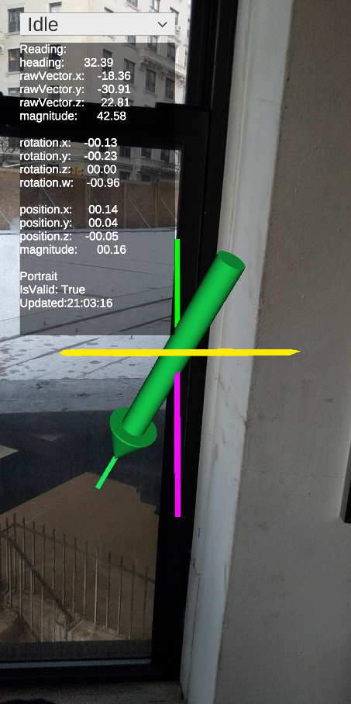

The same view with south-end of static magnet

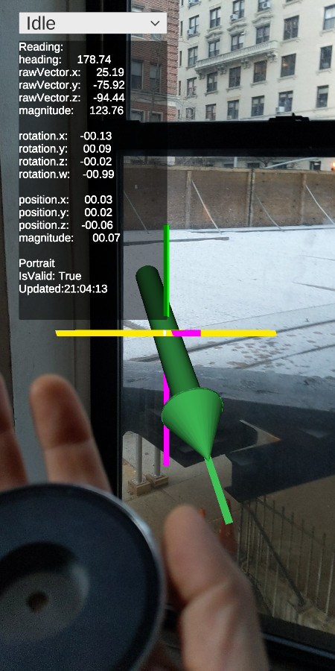

**Continuous Scene**

The Continuous Scene uses Ben Daniel’s C# kd-tree implementation (available here <https://github.com/codeandcats/kdtree>) to construct a 3d binary search tree, and maps the volumes around the device as it moves in space. Each position where a new bounding box is created, a reading is also taken, and both types of rendering for the reading are instantiated. The renderings are placed in the center of the box. A “Read” button begins the field-mapping algorithm, which toggles to “Stop”, which stops the device from taking any more readings. The Unit slider changes the dimensions of the bounding box and renderings. If you click “Show Grid” before you take any readings, the bounding box grid will also be rendered and match the reading’s magnitude color.

Using top (north-end) of static magnet (the metal disk shape in the center of the picture)

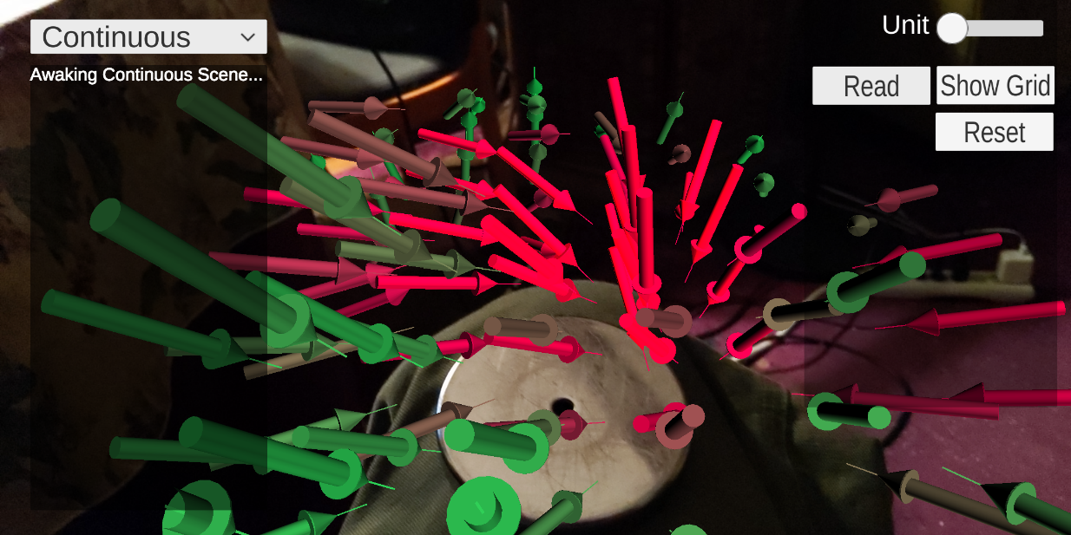

Underside (south-end) of the static magnet

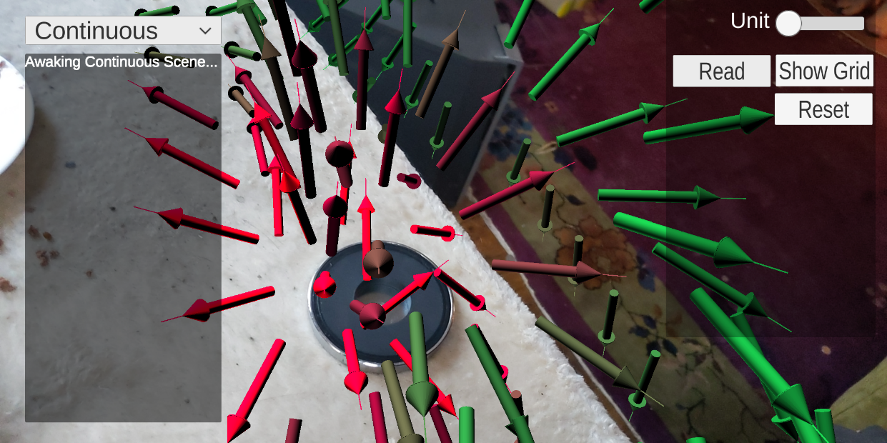

Using solenoid at 5V and 1 amp.

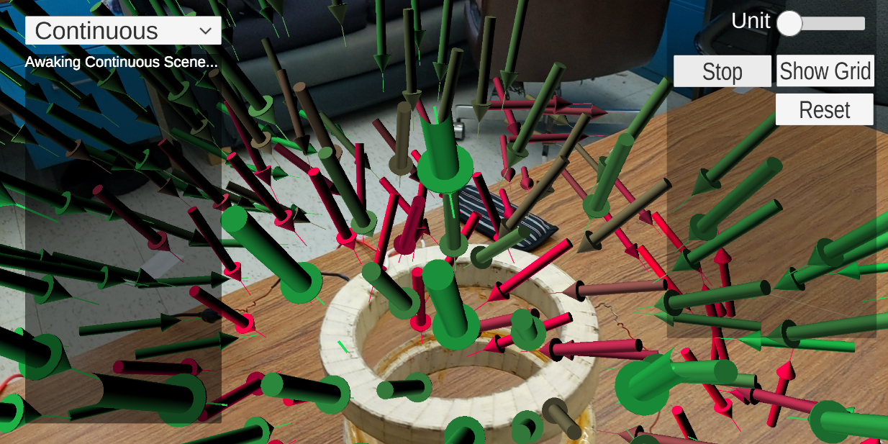

Using solenoid at 12V and 2 amps:

